**Bootstrap**

1. Bootstrap is a powerful mobile first front-end framework for faster and easier web development. It uses HTML, CSS and JavaScript.
2. Bootstrap was developed by Mark Otto and Jacob Thornton at Twitter. It was released as an open source product in August 2011 on GitHub.
3. It is supported by all popular browsers.
4. Why use Bootstrap?
   1. Easy to get started
   2. Responsive design - Bootstrap responsive CSS adjusts to Desktops, Tablets and Mobiles.
5. Bootstrap provides a basic structure with Grid System, link styles, background.
6. Bootstrap comes with feature of global CSS settings, fundamental HTML elements styled and enhanced with extensible classes, and an advanced grid system.
7. Bootstrap contains over a dozen reusable components built to provide iconography, dropdowns, navigation, alerts, popovers, and much more.
8. What Bootstrap Package Includes
   1. JavaScript Plugins: Bootstrap contains over a dozen custom jQuery plugins.
   2. Customize: You can customize Bootstrap's components
9. 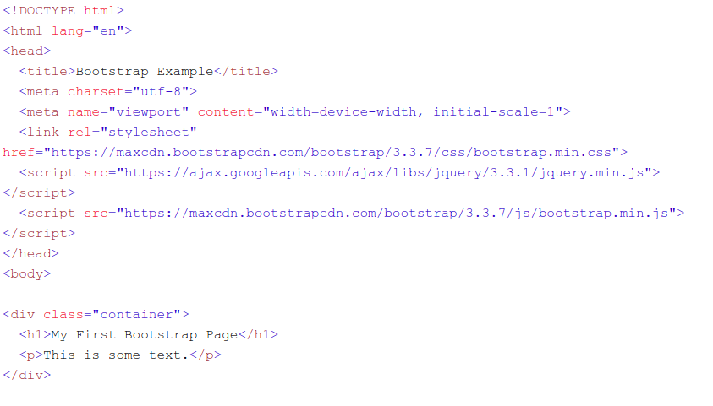
10. What is Bootstrap Grid System
    1. Bootstrap includes a responsive, mobile first fluid grid system that appropriately scales up to 12 columns as the device or view port size increases.
    2. It includes predefined classes for easy layout options, as well as powerful mixins for generating more semantic layouts.
    3. Here's how the Bootstrap grid system works:
       1. Rows must be placed within a .container class for proper alignment and padding.
       2. Use rows to create horizontal groups of columns.
       3. Content should be placed within columns, and only columns may be immediate children of rows.
       4. Predefined grid classes like .row and .col-xs-4 are available for quickly making grid layouts. LESS mixins can also be used for more semantic layouts.
       5. Columns create gutters (gaps between column content) via padding. That padding is offset in rows for the first and last column via negative margin on .rows.
       6. Grid columns are created by specifying the number of twelve available columns you wish to span. For example, three equal columns would use three .col-xs-4.
    4. Basic grid structure
       1. 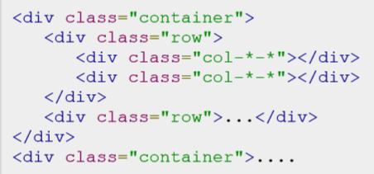
11. Media queries
    1. Media query is a really fancy term for "conditional CSS rule". It simply applies some CSS based on certain conditions set forth. If those conditions are met, the style is applied.
    2. 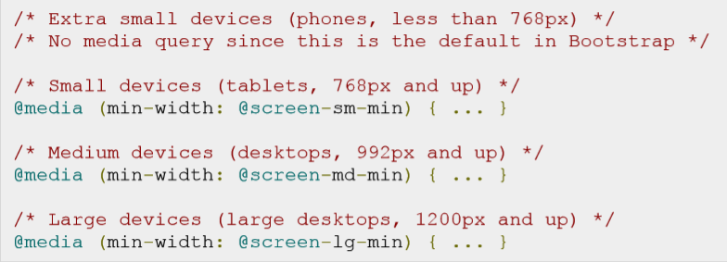
12. Responsive images
    1. Bootstrap 3 allows to make the images responsive by adding a class .img-responsive to the <img>tag.
    2. 
13. Containers
    1. Use class .container to wrap a page's content and easily center the content's as shown below.
       1. <div class="container"> ... </div>
14. Typography
    1. Bootstrap uses Helvetica Neue, Helvetica, Arial, and sans-serif in its default font stack. Using typography feature of Bootstrap you can create headings, paragraphs, lists and other inline elements.
    2. To add an inline subheading to any of the headings, simply add <small> around any of the elements or add .small class and you will get smaller text in a lighter color
    3. Lists
       1. Ordered lists
       2. Unordered lists
15. Tables
    1. If you want a nice, basic table style with just some light padding and horizontal dividers, add the base class of .table to any table - .table
    2. Table-striped
    3. Table-bordered
    4. Table-hover
    5. Table-responsive
16. Forms
    1. Vertical (default) form
       1. 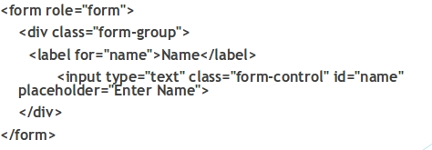
       2. 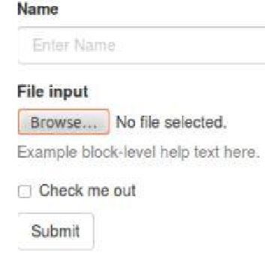
    2. Inline form - form-inline
       1. 
    3. Horizontal form - form-horizontal
       1. 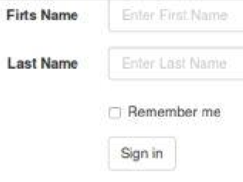
17. Buttons
    1. 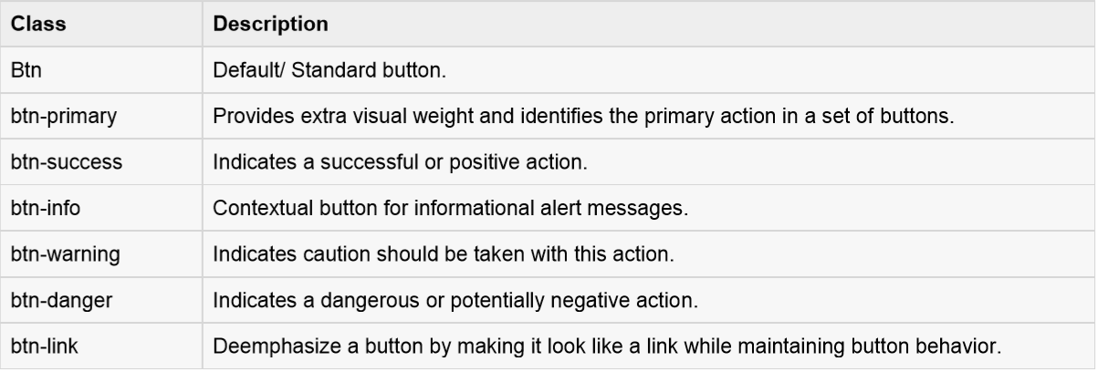
18. Images
    1. .img-rounded: adds border-radius:6px to give the image rounded corners.
    2. .img-circle: makes the entire image round by adding border-radius:500px.
    3. .img-thumbnail: adds a bit of padding and a gray border:
19. Helper classes
    1. Close - Use the generic close icon for dismissing content like modals and alerts.
    2. Carets - Use carets to indicate drop down functionality and direction. To get this functionality use the class caret with a <span> element.

Assignments

1. Convert bootsrap_assignment1.jpg to responsive HTML .
2. Convert bootsrap_assignment2.jpg to responsive HTML .